A CRM APPLICATION FOR THECHAISHOP&CO
1. Brainstorming & Ideation Phase

Project & Team Details
Attribute | Details
Project Title | A CRM Application for TheChaiShop&Co
Domain | Cloud Computing / Salesforce Administration
Platform | Salesforce Lightning Developer Edition
Institution | PS PT MGR Government Arts & Science College, Sirkali, Puthur - 609108 (College Code: ANM403)
Submission Portal | SkillWallet
Team Leader | PRITHIVIRAJ R - (Reg. No. 24134031802521033)
Member 2 | Dharun Mass - (Reg. No. 24134031802521016)
Member 3 | Ajan A - (Reg. No. 24134031802521006)
Member 4 | Sanjai D - (Reg. No. 24134031802521041)
Member 5 | Vigneswaran C - (Reg. No. 24134031802521055)

User Story
As a sales representative at TheChaiShop&Co, I want to efficiently manage customer relationships and streamline sales processes using our CRM application. I want to easily access and update employer details, as well as distinguish between online and offline customer records using record types, allowing for personalized interactions. Additionally, I need the application to automate sales calculations, such as order quantity and total bill amount, to ensure accurate and efficient transactions. Moreover, I require the ability to generate insightful reports and dashboards to summarize and analyze sales data effectively, aiding in decision-making and strategy development. Lastly, I would like the application to automate email notifications to customers on their birthdays, informing them of special offers tailored to celebrate their special day, enhancing customer engagement and loyalty.

1. INTRODUCTION

1.1 Project Overview
The project "A CRM Application for TheChaiShop&Co" focuses on developing a Salesforce-based Customer Relationship Management (CRM) system to manage customer, employer, and enterprise accounts efficiently. The system automates sales processes, maintains customer records, generates reports, and improves customer engagement through automated notifications.

1.2 Purpose
The primary objectives of this project are:
- Streamline customer relationship management across counter sales and bulk orders.
- Automate billing and order calculations using declarative tools.
- Improve business data accuracy through field-level validations.
- Enable data-driven decision-making via real-time summary reports and interactive dashboards.
- Enhance customer engagement and retention through scheduled birthday email notifications.

2. IDEATION PHASE

2.1 Problem Statements
PS ID | Persona | I am trying to... | But... | Because... | Which makes me feel...
PS-1 | Sales Representative | Manage customer orders and billing | Calculations are often incorrect | Order quantity and billing are manual | Stressed and inefficient
PS-2 | Store Manager | Monitor sales and customer records | Reports are delayed and incomplete | Data is stored in multiple files | Confused and dissatisfied
PS-3 | Customer | Receive personalized offers and updates | I do not get timely notifications | There is no automated communication | Disconnected and undervalued

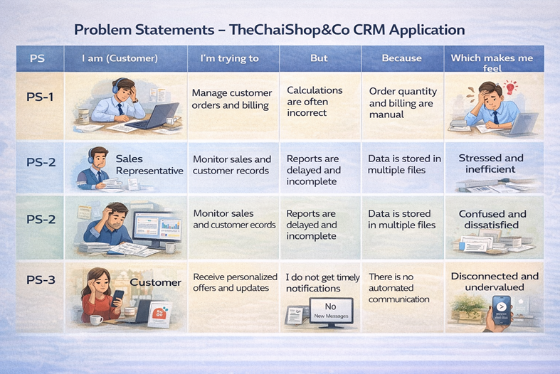

2.2 Empathy Map Canvas
- Target Users: Sales Representatives, Store Managers, System Administrators, Business Analysts.
- Think & Feel: Need accurate customer data and real-time operational reports.
- Hear: Feedback from management regarding report delays; requests for faster checkout.
- See: Multiple registers, paper bills, and spreadsheets on the sales desk.
- Say & Do: Enter data manually into physical registers; manually compute item prices and bulk totals.
- Pain: Human errors, billing delays, communication bottlenecks, and data loss.
- Gain: No-code process automation, rapid reporting, and instant dashboard insights.

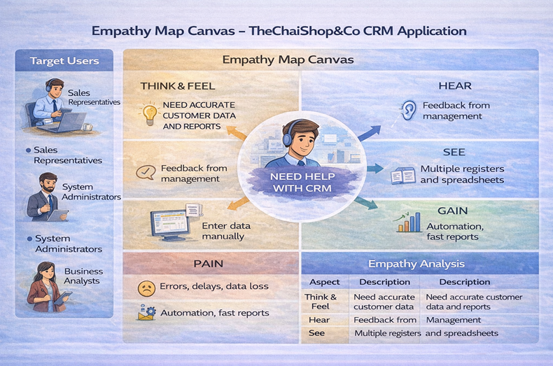

2.3 Brainstorming & Selection
Brainstormed Ideas:
- Manual CRM system
- Excel-based management
- Web-based CRM
- Automated email system
- Salesforce-based CRM
Selected Idea:
Salesforce-based CRM Application for TheChaiShop&Co.
Selection Reason:
Offers a unified cloud platform combining relational database architecture, drag-and-drop UI customization, declarative flow automations, and built-in analytical charts.
